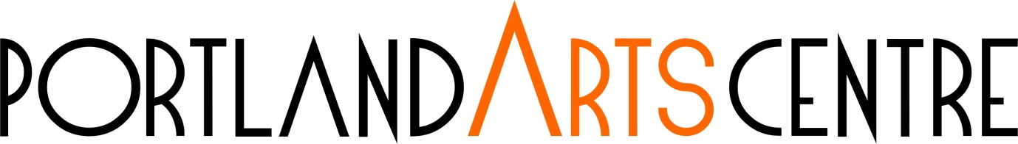APPLICATION TO EXHIBIT IN 2023
Please ensure that you have read the ‘Guidelines for Exhibiting at PAC’ before completing this form. If you require assistance, please contact PAC staff at enquiry@portlandartscentre.com.au
NAME:

ADDRESS:

TELEPHONE: MOBILE:

EMAIL:

WEBSITE:

Please include names and contacts for any co-exhibitors (if applicable). If this is a group application, please enter the names of all exhibitors here:

EXHIBITION OUTLINE: (include the theme of the exhibition you intend to deliver, which mediums are represented in the work, number of works and size if necessary, etc) Approx. 250 words. Use the following questions to help form your outline if required.

- What is the theme of the exhibition?

- Are there any other influences/ what has inspired the work?

- What are the mediums used? If there is more than one, please provide details.

- How many works are being exhibited and what size are they?

- What is being communicated to the viewer?

Please attach:
- Artist’s CV detailing previous exhibitions, significant artistic achievements, an artist summary and other relevant information.
- up to six (6) images indicative of your work or actual works proposed for the exhibition (files no more than 1MB per image) OR link to website
Exhibition dates are 13 April – 18 June 2023 with install and de-install prior to and after these dates.

Please email completed form and support material to:
enquiry@portlandartscentre.com.au
with ‘2023 Exhibition application’ in the subject
BY 5PM 27 January 2023

OR post to

Portland Arts Centre
Glenelg Shire Council
P.O. Box 152
PORTLAND VIC 3305
ATTN: 2023 Exhibition application

For further information please contact:

ahawkins@glenelg.vic.gov.au or 5522 2326

NB: Please retain a copy of this form and advise of any alterations to the above information. This information will be used when exhibitions are programmed for PAC.

NOTIFICATION:
Completion of this form does not guarantee an exhibition.
Artists will be notified by 5pm 3 February 2023 if they have been selected to exhibit in 2023. Successful applicants may be required to submit additional information.

